# DECLARATION/CONSENT

I, …………………Akshay k…………………………., aged ……22.. years, S/o …………Chandran k…………………….., residing at …Akshaya, uppaichal road azhikode kannur 670009……………., do hereby declare as under:

1. That I am a candidate who appeared forthe IELTS Academic/General examination on ………………………….**OR** aiming/planning to write the same on or before March 15, 2023.
2. That I have come to know from Santamonica Study Abroad Pvt. Ltd. (“Santamonica”) that, at present, there is a limited period scheme/offer in place whereby I could get my IELTS examination fee reimbursed, but subject to specific terms and conditions.
3. That I have been made fully aware of the above-referred terms and conditions, and there forth, I clearly understand that the reimbursement mentioned above is only a conditional offer subject to strict compliance from my part in accordance with such terms and conditions, and is not a guarantee as such; moreover, I do know that there could be other extraneous factors that may affect the final fulfilment of such offer.
4. That I fully know that the above offer is in place in connection with the Concordance Study Projectof PeopleCert International Limited (“PeopleCert”), and their association with Santamonica for assistance in that regard.
5. That, accordingly, I have executed the Microsoft Form, namely “Concordance Study-Application and Registration Form- India(Santa Monica-6442) Group A” owned by PeopleCert and shared with me by Santamonica.
6. That I hereby assure to cooperate fully and comply with the conditions and instructions that PeopleCert and Santamonica have already set forth, and that they may deem necessary to set forth in futurein the matter, and to take earnest efforts towards writing the required LanguageCert and IELTS examinations in true spirit and within the stipulated timeframe.
7. That I have no objection whatsoever as to sharing my IELTS score with Santamonica and PeopleCert as I do comprehend the same to be inevitable for meeting the very objective of theConcordance Study Program by PeopleCert. I further understand that my score for the relevant LanguageCert examination will not be disclosed to me and it cannot be put in use by me in any manner since the exam is conducted only for the analytical/comparative purpose by PeopleCert for its Concordance Study Program.
8. That I realize and accept the fact that the above-mentioned arrangement is made known to me by Santamonica in the best of my interest and that there has been no compulsion, or false or misrepresentation from their end in that direction. Consequently, I cannot blame and/or make any claim whatsoever against Santamonica as to the reimbursement/refund on offer because such refund/reimbursement is to be initiated by PeopleCert at its sole discretion after making an overall analysis of the compliance/performance in each candidate’s case.

I do hereby affirm that this declaration is being signed by me voluntarily, and with my own free will and consent, and after thoroughly reading and clearly understanding each and every part/aspect of it and all consequences that may arise/ensue out of it.

Date[dd/mm/yyyy]:4-3-2023 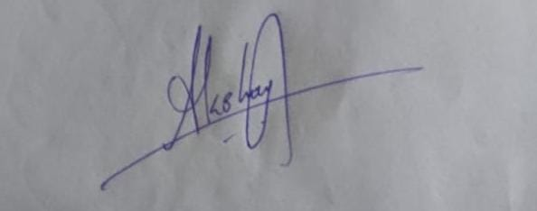

Place:Kannur Signature of the candidate